PROJECT REPORT
AI-Powered Trending Topic & Content Idea Generator

Submitted By:
Name: Esther Dreama Pinto
Course: BBA in Data Science & Artificial Intelligence
College: Kristu Jayanti College, Bengaluru
Project Title: AI Trend Hunter
1. Introduction
AI Trend Hunter is a web-based application developed using Python and Streamlit. The application helps users discover trending topics, generate content ideas, and receive hashtag suggestions based on their business category. The project demonstrates how Artificial Intelligence can simplify content planning and improve digital marketing strategies.
2. Problem Statement
Many businesses and content creators struggle to identify trending topics and create engaging content consistently. Searching for trends manually is time-consuming and often ineffective.
3. Objectives
Build an AI-powered web application.
Generate trending topics based on user input.
Suggest content ideas.
Recommend relevant hashtags.
Create a simple and user-friendly interface.
Demonstrate AI integration using the Gemini API.
4. Proposed Solution
The proposed system accepts a business category entered by the user. Based on the input, the application generates:
Trending topics
AI-generated content ideas
Relevant hashtags
Trend score
The results help users quickly plan social media content.
5. Features
Simple and attractive user interface
Business category input
AI-generated trending topics
Content idea suggestions
Smart hashtag generation
Trend score display
Responsive Streamlit application
6. Technologies Used
Python
Backend programming
Streamlit
Web application development
VS code
AI content generation
Google Trends
Trend data
GitHub
Streamlit Cloud
Project deployment
7. System Architecture
User Input
↓
Python Processing
↓
Gemini API / Trend Dataset
↓
Generate Results
↓
Display in Streamlit
8. Implementation
The project was developed in Python using Streamlit.
The application accepts a business category from the user. Python processes the input and sends it to the Gemini API (or simulated trend logic). AI generates trending topics, content ideas, and hashtags. These results are displayed on the Streamlit interface.
The project was developed using Visual Studio Code and deployed using GitHub and Streamlit Community Cloud.
9. Working of the Project
Step 1: User opens the application.
Step 2: User enters a business category.
Example: Fashion
Step 3: User clicks Find AI Trends.
Step 4: The application processes the request.
Step 5: AI generates:
Trending Topics
Content Ideas
Hashtags
Trend Score
Step 6: Results are displayed instantly.
10. Screenshots

Screenshot 1: Home Page
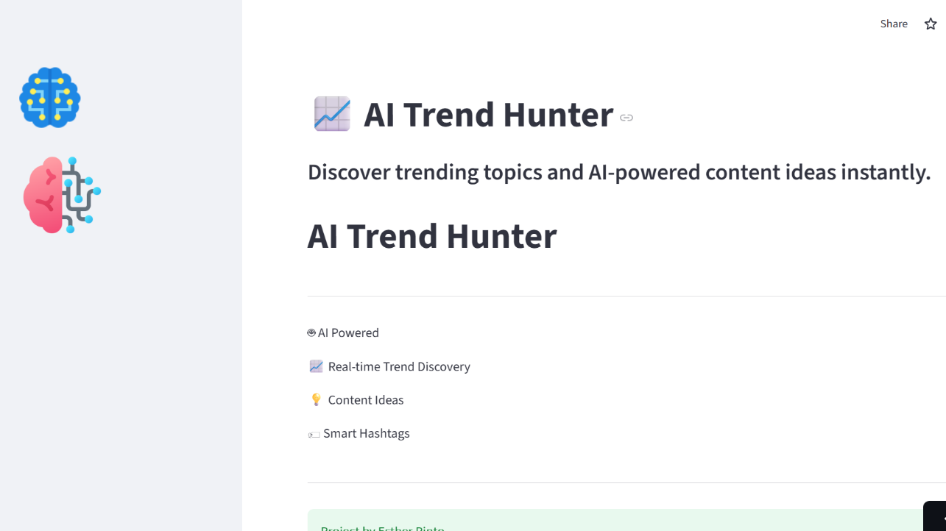
Screenshot 2: User Input

Screenshot 3: Trending Topics Generated
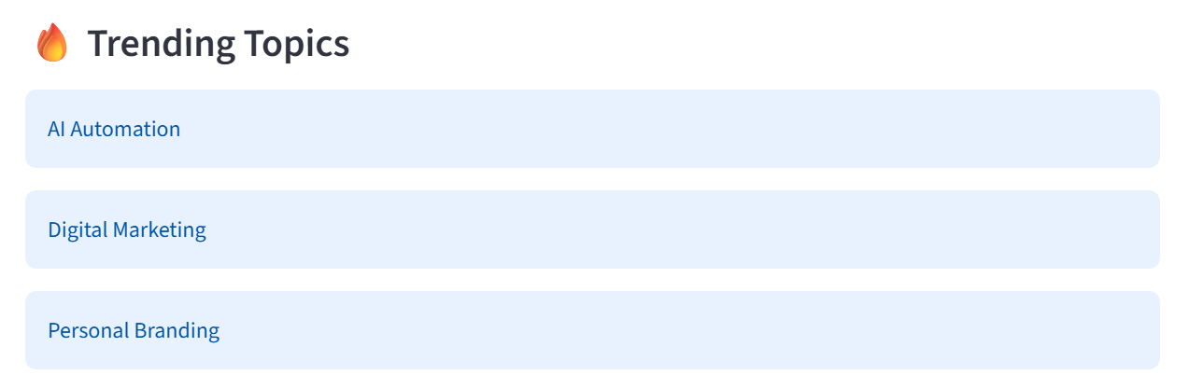
Screenshot 4: Content Ideas
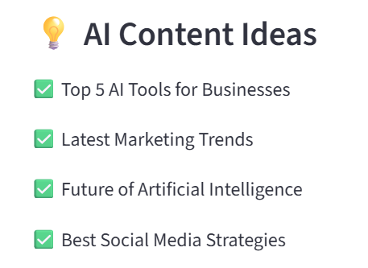
Screenshot 5: Suggested Hashtags
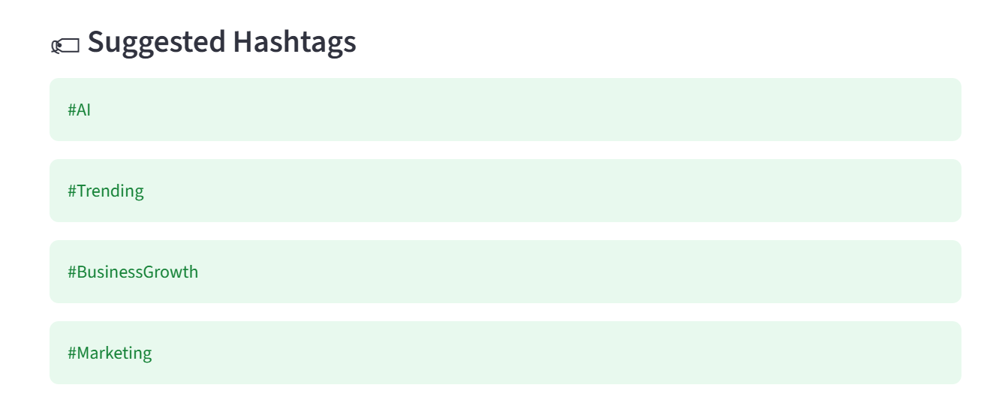
Screenshot 6: Final Output
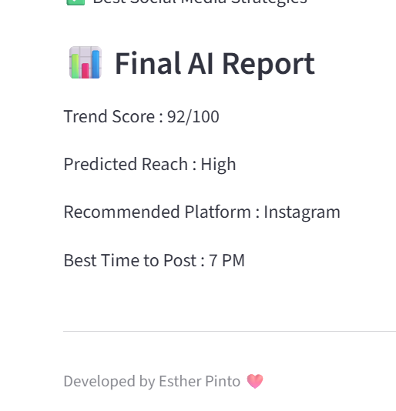
Screenshot 7: GitHub Repository
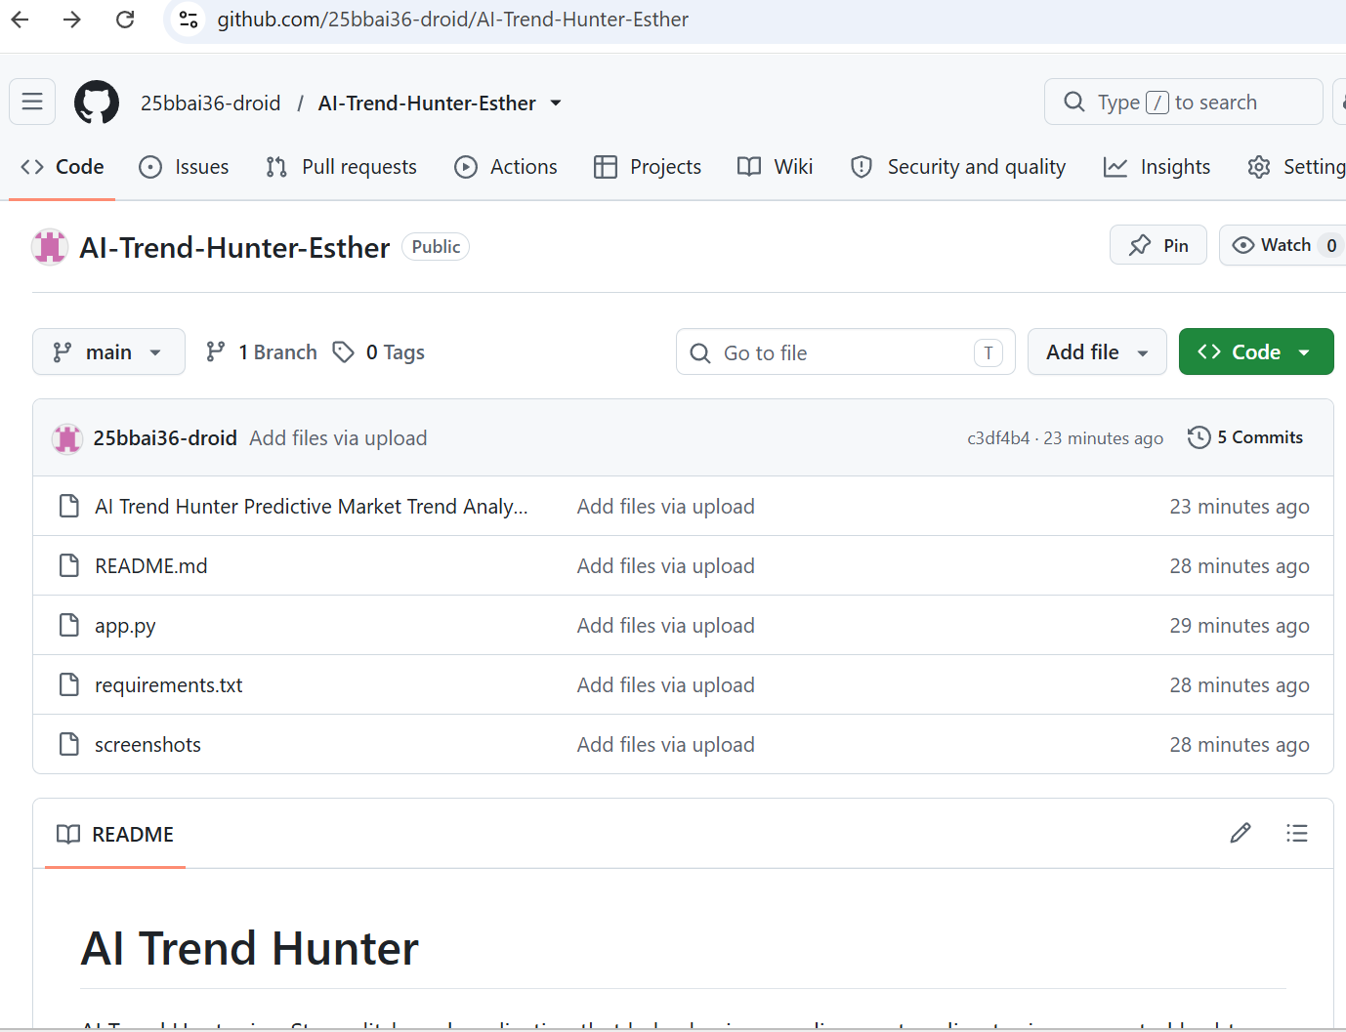

11. Advantages
Easy to use
Saves time
AI-powered suggestions
Attractive interface
Helpful for businesses and creators
Beginner-friendly
Can be deployed online
12. Limitations
Depends on AI responses.
Internet connection is required.
Trend accuracy depends on available data.
Limited free API usage.
13. Future Scope
Future improvements include:
Live Google Trends integration
User authentication
Content calendar generation
Export results as PDF
Multi-language support
Social media post generation
Analytics dashboard
14. Learning Outcomes
Through this project, I learned:
Python programming
Streamlit development
GitHub repository management
Web application deployment
AI integration using Gemini API
Project documentation
Problem-solving skills
15. Conclusion
AI Trend Hunter successfully demonstrates how Artificial Intelligence can simplify trend discovery and content planning. The application provides users with trending topics, content ideas, and hashtags through an easy-to-use interface. This project helped strengthen practical skills in AI, Python, web application development, and deployment.
16. References
Streamlit Link: https://ai-trend-hunter-esther-bejyuwatycd5tak5t3semv.streamlit.app/
Github Link: https://github.com/25bbai36-droid/AI-Trend-Hunter-Esther

